Class Assignment 8

JQuery, JQqeryUI, and JQuery UI Interaction

1. Create a HTML page with an 3 connected sortable list (1 mark).

2. Create a page with 2 connected sortable list with a draggable item at the top. You should be able to move items from one sortable list to another. Also you need to be able to drag the draggable item in both of the sortable list. (1.5 marks)

**Use JQuery Framework and JQuery UI to solve the problem.**

**Step by step browse:**

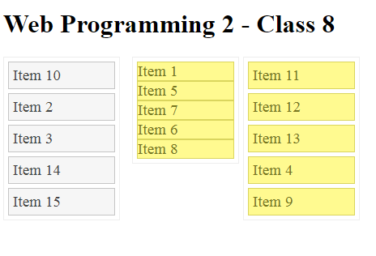

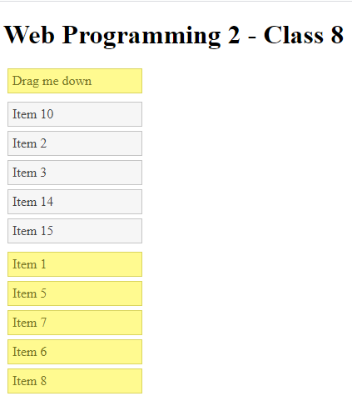

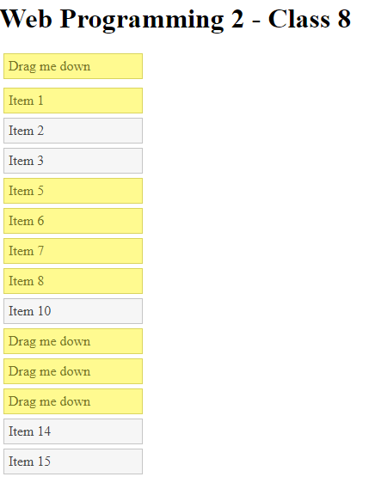

**How to submit:**

Compress the folder.

Take Screen Shots of your HTML, CSS, and JavaScript codes attach those to this file.

Upload the compressed folder and word document in moodle.

**Answer here:**

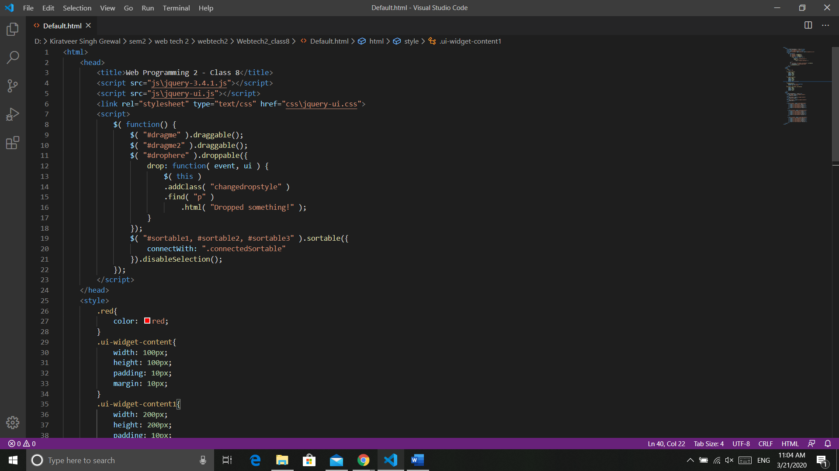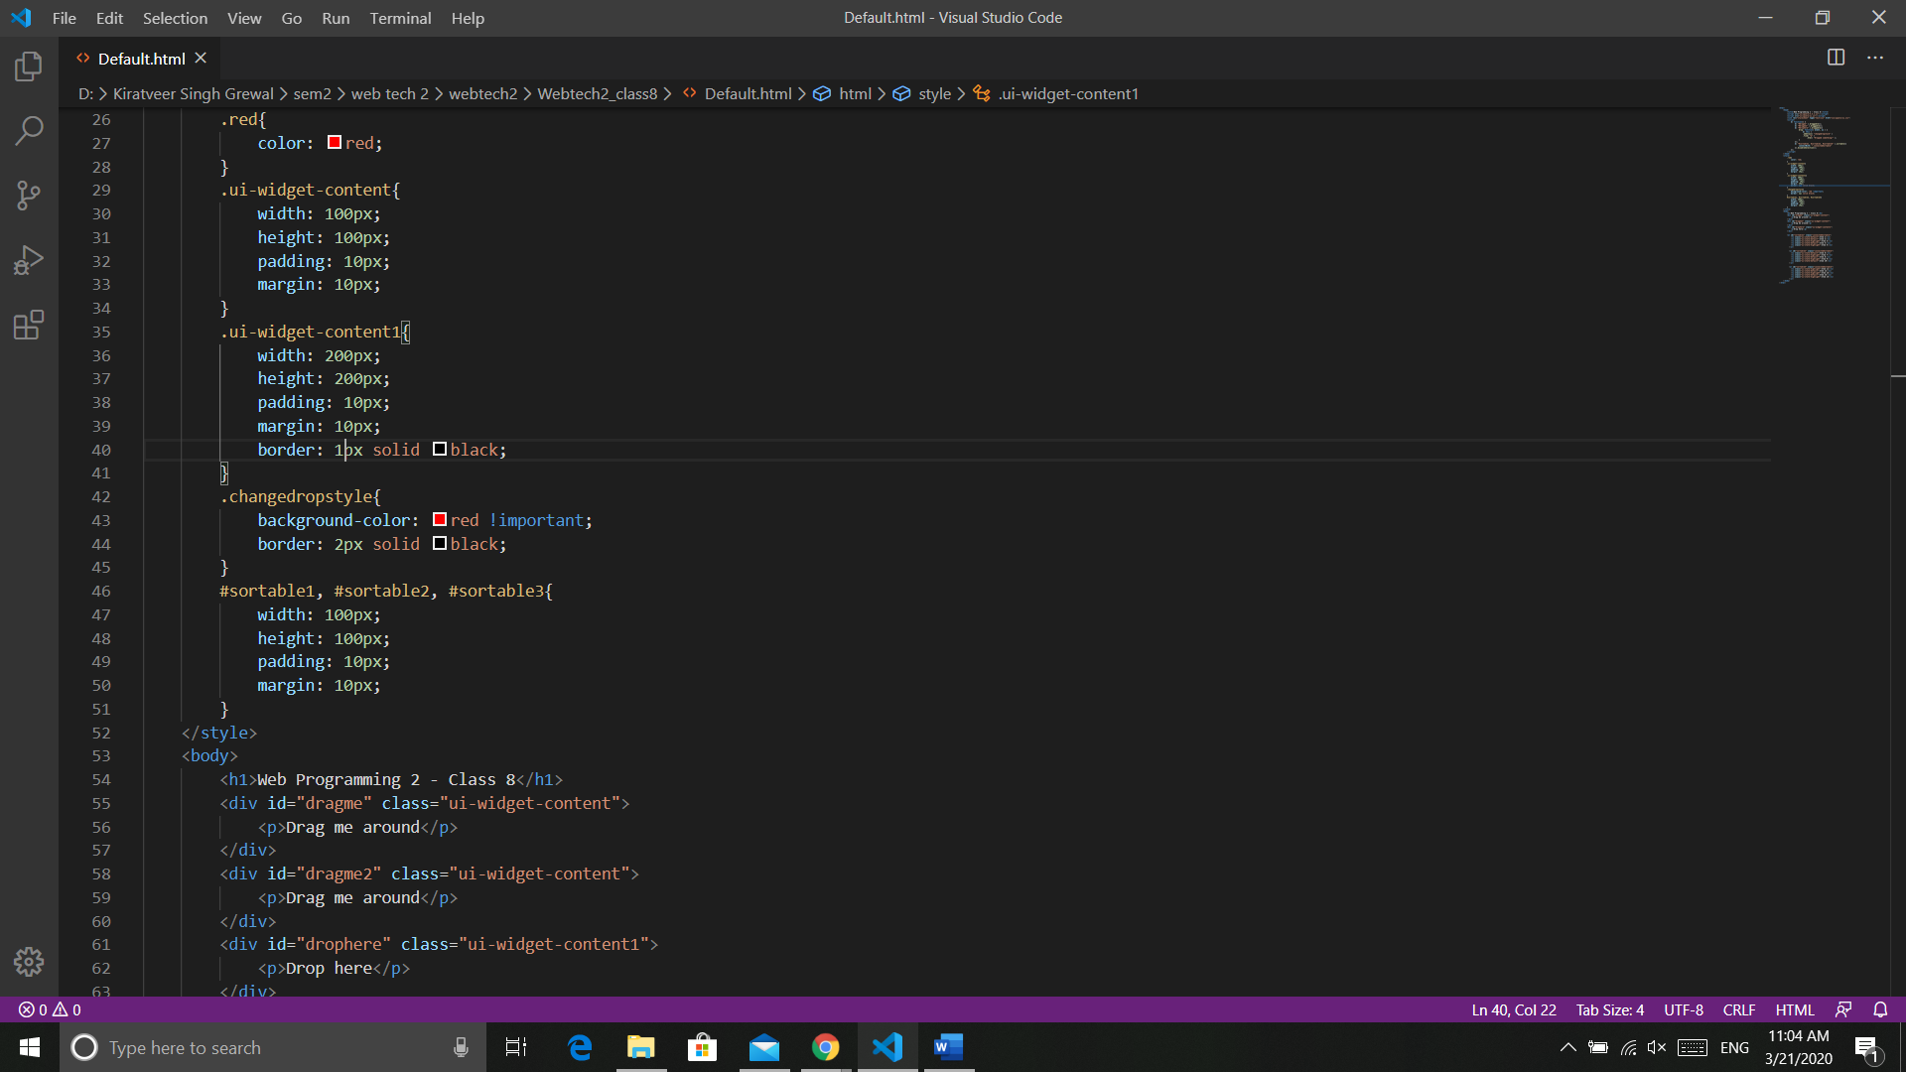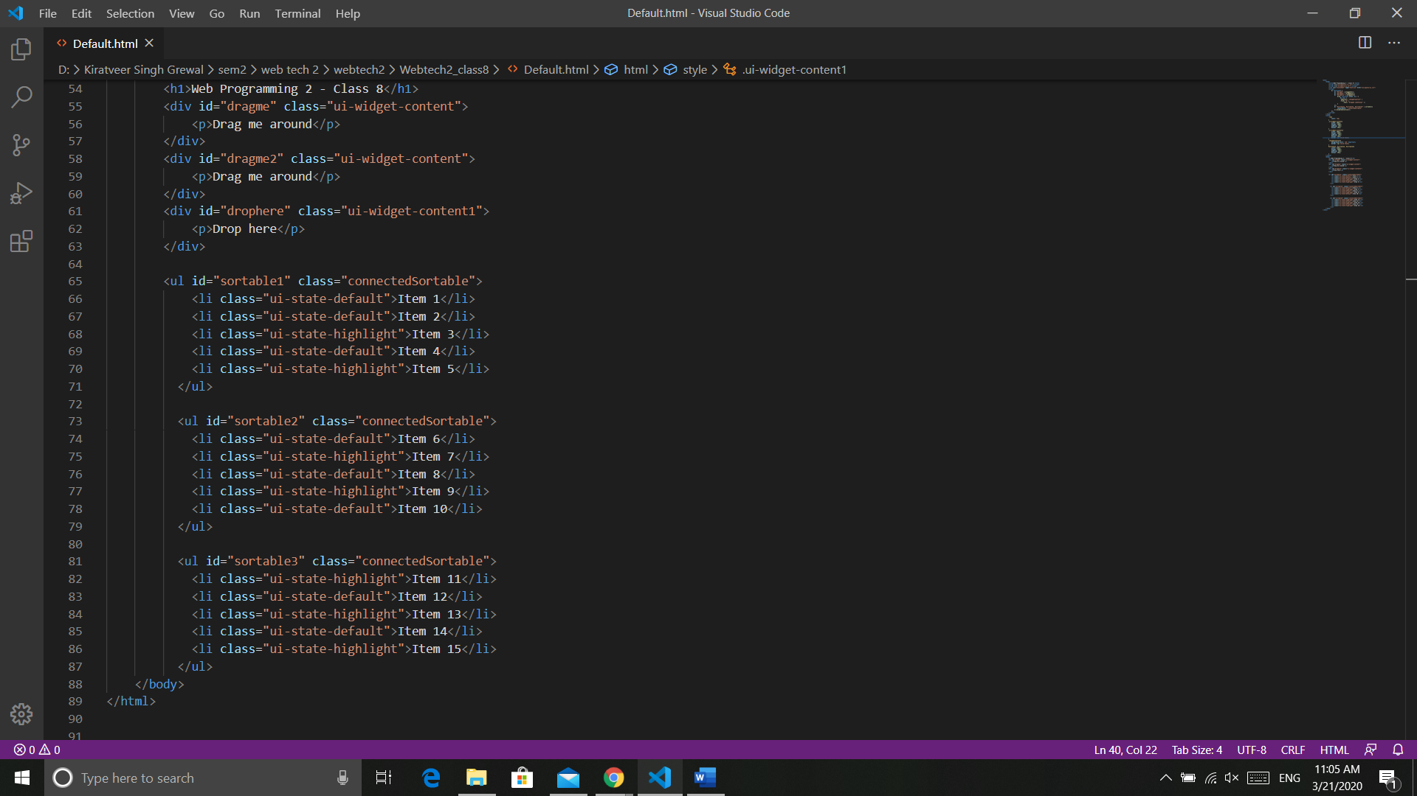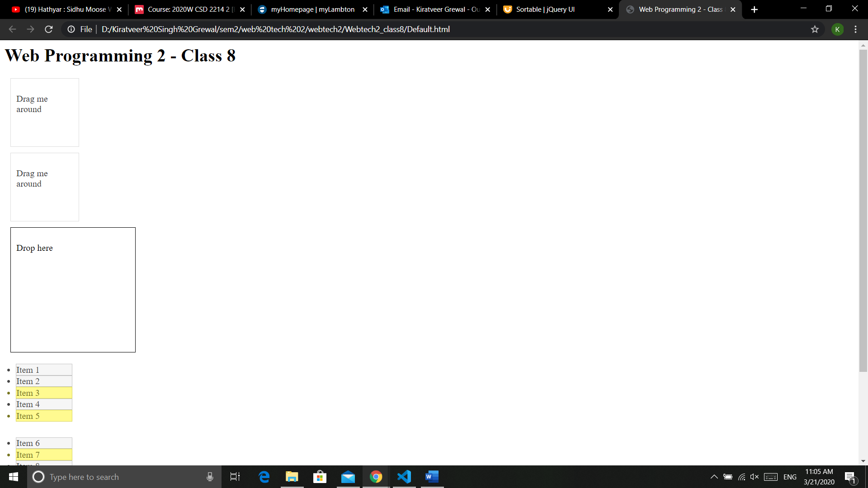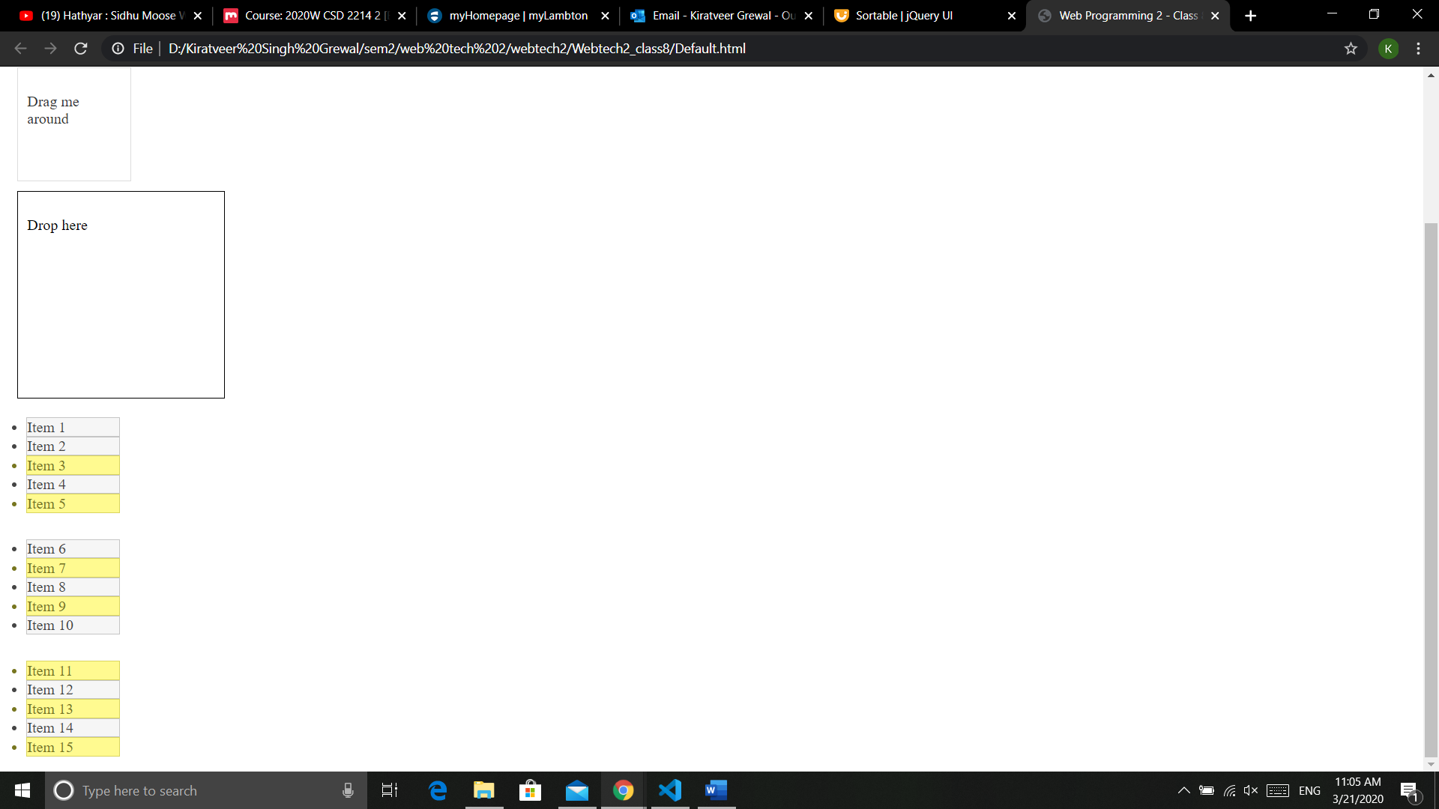

After sorting